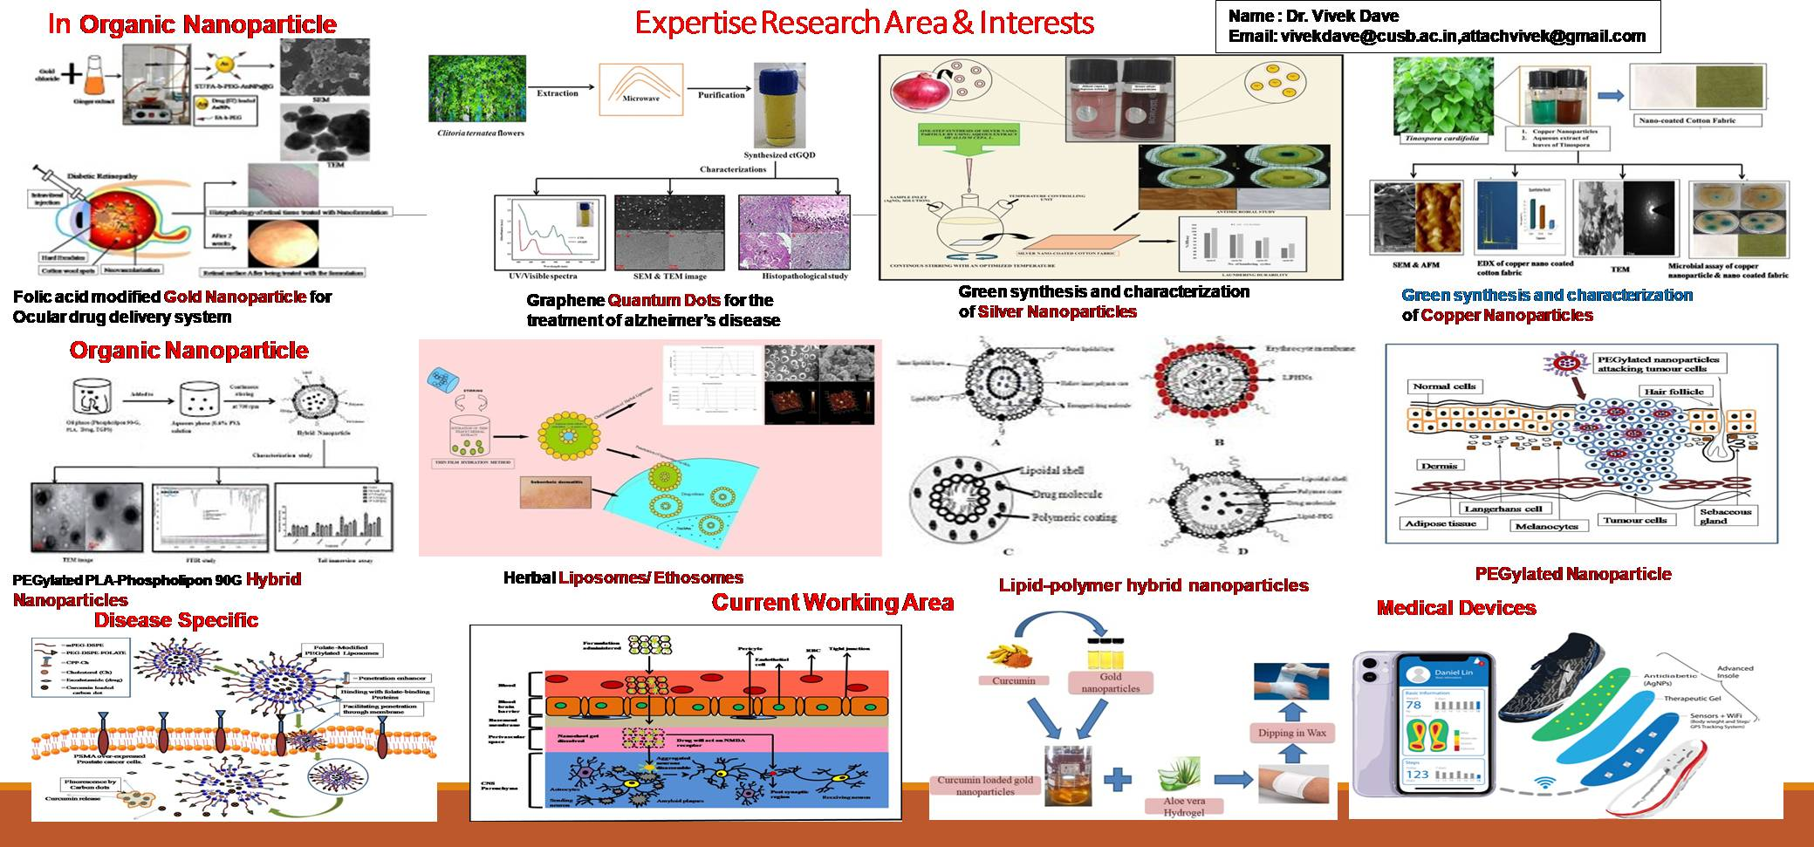
Dr. Vivek Dave
B.Pharm., M.Pharm., Ph.D. (Pharmaceutics)

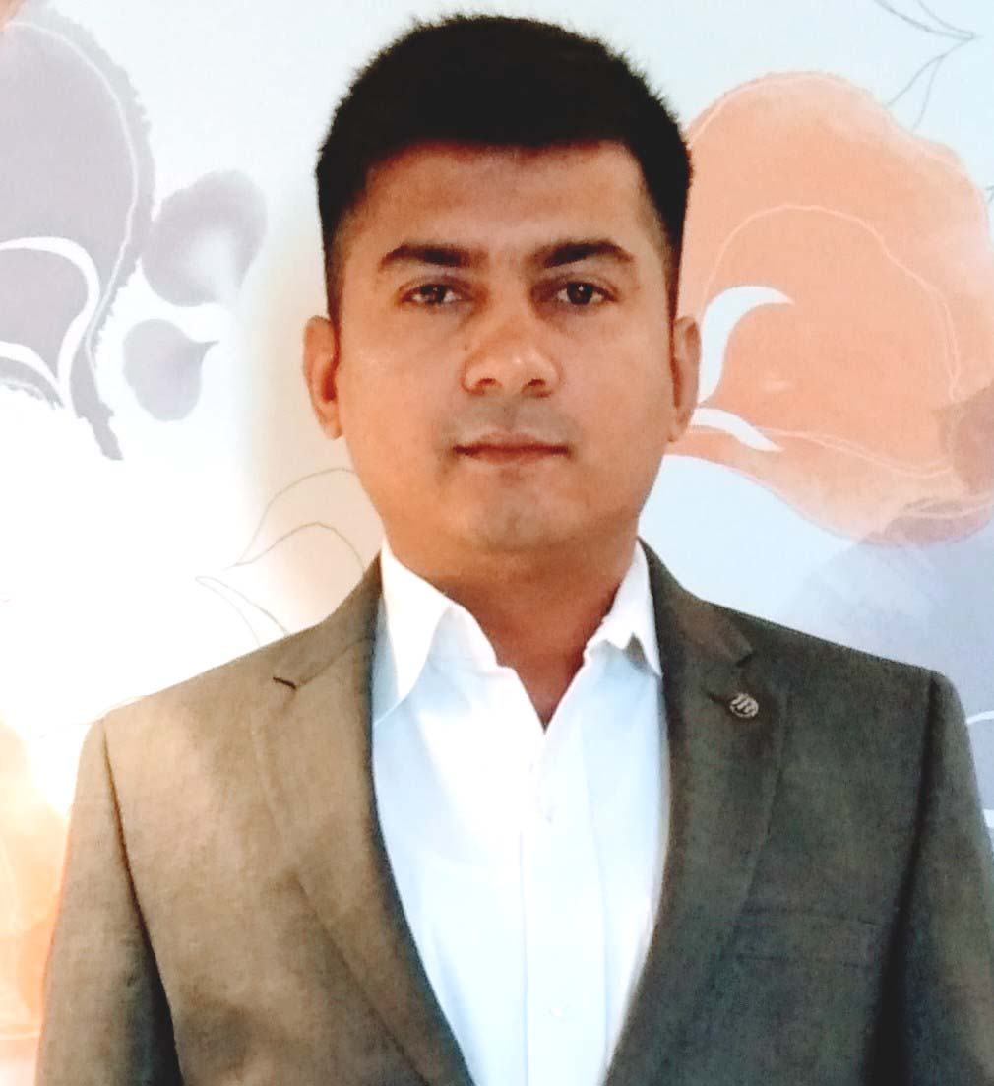 |  | Designation |  |  | Dean: School of Health Science  Head: Department of Pharmacy  Associate Professor
 |  | Department/Faculty |  |  | Department of Pharmacy,  School of Health Science
 |  | University |  |  | Central University of South Bihar,  Bihar -824236
 |  | Address Campus/  Residence |  |  | Department of Pharmacy,  School of Health Science  Central University of South Bihar,  Bihar -824236
 |  |  |  |  | 66, Saraswati Colony, Damoh, 470661, Madhya Pradesh
 |  | Phone (M) |  |  | +91-8949312523, 9694891454
 |  | Skype ID |  |  | attachvivek
 |  | E-Mail |  |  | vivekdave@cusb.ac.in  attachvivek@gmail.com vivekdave1984@gmail.com,
Objective |  | - To work in the challenging position with an organization that provides ample opportunities to learn and to contribute.  - Acquired knowledge of new methods, technology and industrial trends while undertaking projects.  - Adapt in facilitating an intellectual growth by creating an atmosphere of mutual respect and open communication.
Summary of Qualifications

Degree/Diploma  (Year) |  | Institution |  |  | Details
Ph.D. (Pharmaceutics) (2010 – 2014) |  | Banasthali University, Rajasthan. |  |  | Thesis topic: “Design and evaluation of aceclofenac & esmolol HCl containing ocular drug delivery system”.
M.Pharm. (Pharmaceutics)  (2006 – 2008)  Secured 70% marks. |  | Manipal University,  Manipal, Karnataka. |  |  | Thesis topic: “Aceclofenac ethosomes for enhanced transdermal drug delivery system”.
B.Pharm.  (2002 - 2006)  Secured 65% marks. |  | R.G.P.V University, Madhya Pradesh. |  |  | RKDF College of Pharmacy, Bhopal, Madhya Pradesh
XII.  ( 2002)  Secured 72% marks. |  | Board of Secondary Education, Madhya Pradesh |  |  | Nav-Jagriti School, Damoh, Madhya Pradesh
X.  ( 2000)  Secured 68% marks. |  | Board of Secondary Education, Madhya Pradesh |  |  | Nav-Jagriti School, Damoh, Madhya Pradesh
*Ph.D. degree is in accordance with the provision of the UGC regulation 2009.

Computer Expertise | Proficiency in operation of MS Word, MS Excel, MS Power-Point, Windows and Internet.
Registered Pharmacist | 16549 (Madhya Pradesh State Pharmacy Council)
Technical skills
- Proficient knowledge of techniques involved in preparation and characterization of novel drug delivery systems e.g. ethosome, nanoparticles, microspheres, ocular inserts, liposomes etc
- ICH guidelines
- (IPR), economic importance, mechanism for protection of intellectual property-patents, copyright, trademarks; role of IP in pharmaceutical industry.
- Related Quality Systems: Objectives and guidelines of USFDA, WHO and ICH. Standard institutes & certification agencies like ISI, BSS, ASTM, WHO, US-FDA, UK-MCA, TGA, Copyright (Indian) Act.
- Technology Development/Transfer Commercialization related aspects transfer of technology (TOT), bottlenecks, managing technology transfer, guidelines for research students, scientists and related personnel, TOT agencies in India APCTD, NRDC, TIFAC, IBCIL, TBSE/SIDBI. TOT related documentation: Confidentiality agreements, licensing, MOUs, legal issues
- Experience in operating instruments like HPLC, Texture analyzer, Malvern zetasizer, UV-Visible spectrophotometer, Spectroflourimeter, Sonicator, Homogenizer, Rotary vacuum evaporator, Buchi mini spray drier, Dissolution Apparatus, Modified Tablet Punching Machine, Goniometer, Rheometer, Lyophilizer, DSC, TGA, FTIR, Exacta coat spray coater etc.
- Knowledge of Intellectual Property Rights (IPR), patents analysis, patent drafting and technology transfer.
- Formulation of solid oral dosage forms, preformulation studies etc

Research Interests/Specialization/ Instruments Knowledge

Highly versatile individual with 10 years of in-depth knowledge of teaching principles, research and development experience. Proven ability to coordinate and execute research studies in Pharmaceutical technology, NDDS and establishing the necessary processes/ procedures for research activities in animal experiments.
- Tablet Compression Machine, Tablet press
- Viscometer Brookfield
- Conventional and Auto Coating Machine
- Fluid bed drier, Vibratory sifter
- Rapid Mixer Granulator
- GEA high pressure homogenizer for Nanosuspension formulation.
- Prob sonicater
- DSC/TGA/ATR/Raman

Professional Experience
(Teaching: 14 Years 2 Months 27 days)

Institution |  |  | Designation and Duration |  |  | Role
Central University of South Bihar, Bihar |  |  | Associate Professor  (26 May. 2020 – Till Date) |  |  | Teaching and Research.
Banasthali University, Rajasthan. |  |  | Assistant Professor  (22 Feb. 2012 – 24 May 2020) |  |  | Teaching and Research.
Himalayan Pharmacy Institute, Sikkim, |  |  | Assistant Professor  (07 Feb. 2011 – 21 Feb. 2012) |  |  | Teaching and Research.
Oriental College of Pharmacy, Bhopal, Madhya Pradesh |  |  | Assistant Professor  (21 Feb. 2008 – 05 Feb. 2011) |  |  | Teaching and Research.
Conferences /Awards/Achievements

- Resource person AICTE- Scheme for Promoting Interests, Creativity, and Ethics among Students (SPICES) supported club, national conference on Intellectual Property Rights of Pharmaceuticals 2.0 held on 07 May 2022 organized by PSIT (Pharmacy), Kanpur, India.

- Invited talk on preclinical screening society of medical scientists of India, innovative approaches in health care and disease organized by department of biochemistry, L.L.R.M.Medical College, Meerut.
- Delivered Expert Lecture on topic Ophthalmic Product vs Ocular drug delivery system “ I Academic on Pharmaceutics & Pharmacology Dated 17 november 2021 workshop Emerging sophisticated analytical techniques” Department of Pharmacy, University of Kota, Kota, Rajasthan

- Invited talk on Scope in Pharmaceutical Science for during 10th WORLD PHARMACIST DAY on 25th September 2020 in Om Sadashiva College of Pharmacy,
Jasidih, Deoghar, Jharkhand-81 41 42
- Participated & Completed successfully AICTE Training And Learning (ATAL) Academy Online FDP on "Drug Engineering" from 2020-9-21 to
2020-9-25 at Bombay College of Pharmacy
- Resource person AICTE sponsored online short term training program, importance of research methodology in clinical research organized by PSIT Kanpur, 14/12/2020 to 19/12/2020.1 41 42
- GOT "Best Sustainability Award" for work on One Soul One Sole in 2019 International Conference on Future Healthcare and Economic Development. Medical Device Innovation Center (MDIC), National Cheng Kung University , Taiwan
- Attended 2019 International Conference on Future Healthcare and Economic Development, Medical Device Innovation Center (MDIC), National Cheng Kung University, Taiwan
- Invited talk on Characterization of NDDS “ Emerging sophisticated analytical techniques” Department of chemistry, Banasthali Vidyapith Nov 1-21, 2017
- Invited talk Nano Zetasizer : a key tool on nano particle characterization Interdisciplinary dimensions of chemical engineering, Dept. of chemical engineering, Banasthali Vidyapith, Rajasthan 21-27 july 2018
- National conference on recent advance in basic science research (NCRABSR-2018) Dec 21-22, 2018, Banasthali Vidyapith, Rajasthan.
- Invited talk on Pharmacy as health care, GUJCOST sponsored one day national seminar on Role of pharmacoeconomics in india health care orgainzed by Dr. Dayaram patel pharmacy college, Bardoli 20 january 2018.
- Faculty development program sponsored by ministry of human resource development “ Electroanalytical techniques – an emerging tool in research, March 29 to April 3 2017 banasthali vidhyapith, Rajasthan
- University innovation cluster – biotechnology instrumentation for academia- industry interface organized by centre for converging technology, university of rajasthan. Jaipur and ayushraj enterprises pvt.ltd 19-20 august 2016
- Research paper entitled “Design & development of celecoxib loaded silver nanoparticles for the treatment of colorectical cancer ” presented at national seminar on instrumentation and characterization technique (DST-CURE Sponsored) on banasthali vidyapith, banasthali, rajasthan, India on 22-23 December 2016
- Research paper entitled “Naproxane loaded guggulosome for enhanced transdermal drug delivery” BEST ORAL presented at national symposium on “drug development through natural product” on maharaja agrasen university, Solan, Himachal Pradesh, India on 11 February 2017.
- Research paper entitled “Formulation and evaluation of aceclofenac ocular drug delivery system.” presented at AICTE sponsored national seminar on “Morden Trends in phytopharmaceutical Drug Development” at Balaji Group, Jaipur, Rajasthan, India on 17-18 August 2012.

- Research paper entitled “Superior Delivery of Drug Permeation through Skin by Ethosomal Gel Using Herbal Polymer.” presented at an international conference Shaastrarth 2013 on rungta college of pharmacy, bhilai, chhattisgarh, India on 8-9 February 2013.ISBN - 978-81-265-4073-0
- Research paper entitled “Ocular Insert for Controlled Delivery of Aceclofenac : Prepration and Evaluation” BEST ORAL presented at national conference on “Comparative analysis between conventional & current research trends in pharmacy” on Invertise University, Bareilly U.P, India on 16 September 2012.

- Second International Conference and Indo-Canadian Satellite Symposium on Pharmaceutical Sciences, Technology, Practice and Natural Health Products, JSS college of pharmacy, Ooty, 24-26, Feb 2007.

- AICTE sponsored “Trends in Marketing of Biopharmaceutics, Cosmeceuticals and Nutraceuticals”. Manipal University, Manipal, India, January 29-31 2007.

- AICTE Sponsored staff development program on “Globalizing Indian herbal formulation: bottlenecks and solution”, Held at Columbia institute of pharmacy, Raipur, Chhatisgharh, 8-19 February 2013.

- International Conference on “Frontiers in Pharmaceutical Sciences and Research: Cutting edge technology in New Drug Discovery and Drug Delivery Systems” organized by Columbia institute of pharmacy, Raipur, Chhatisgharh, in association with society for ethnopharmacology, India. Title: legal agreements & documentation related to technology transfer in global pharmaceutical industry, 11-12 October 2014.

- National conference emerging trends in chemical & pharmaceutical sciences, supported by department of science & technology, New Delhi., Title: Formulation factor of esmolol HCL eye drops efficiency evaluation based on physicochemical characteristics in-vitro and in-vivo permeation. Department of pharmacy, Banasthali University, Rajasthan, March 12-13 2015.

- National workshop on sustainable mental health : an insight into the learner world , March 23-29 2017, Banasthali University, Rajasthan

- National conference on recent advances in basic science research (NCRABSR-2018) faculty of life science Banasthali University, Rajasthan December 21-22, 2018

- Workshop on Intellectual Property and innovation management in knowledge era organized by banasthali vidyapith 5 December 2015

- Emerging carerrs in pharmaceutical industry 25 Feb. 2017, IIHMR University, Jaipur in associated with IPGA

- Invited talk ICMR and DST sponsored national conference on innovative drug delivery system theme flaunting research and innovatives DDS technology organized by laureate institute of pharmacy kathog, kangra H.P Design advancement & characterization of fast dissolving tablet by fusion method 22-23 august 2014

- Organizer Prof. Diwakar Shastri Health Camp, Banasthali University, Rjasthan

- Successfully completed “General Course on Intellectual Property” conducted by World Intellectual Property Organization, Geneva.
- Runner up in Cricket Competition for the year 2006-07, held at Manipal University.
- Participated in under-16 state level cricket.
- Participated in cultural events at school level and won prizes in the same.

Chapters

- Green and Sustainable Advanced Materials – Environmental Applications. Swapnil Sharma, Vivek Dave, Kanika Verma, Jaya Dwivedi. Green and Sustainable Advanced Materials, Volume 2, Applications Edited by Shakel Ahmed and Chaudhery Mustansar Hussain. Publisher Willey. October 2018, ISBN: 978-1-119-52848-7

- “ALGINATES- Food Industry and Biomedical Applications” Alginates in pharmaceutical and biomedical application: A critique Vivek Dave, Kajal Tak, Chavi Gupta, Kanika Verma and Swapnil Sharma Publisher Willey. March 2019, ISBN: 978-1-119-48791-3

- Nanopharmaceutical Advanced Delivery systems , Phytosomes – Nanoarchitectures Promising Clinical Applications and Therapeutics, Pankaj Pal, Vivek Dave, Shailendra Paliwal, Monika Sharma, Mrugendra B. Potdar, Avnica Tyagi, Publisher Willey, January 2021, ISBN: 978-1-119-71166-7, DOI https://doi.org/10.1002/9781119711698.ch9

- Nanopharmaceutical Advanced Delivery systems , Recent advances in polymer-modified liposomes for the cancer treatment, Swapnil Sharma, Akansha Bisht, Sanjana Tewari, Vivek Dave, Publisher Willey, January 2021, ISBN: 978-1-119-71166-7,page 379-405. DOI: 10.1002/9781119711698.ch17

- Nanopharmaceutical Advanced Delivery systems Current frame work, ethical consideration and future challenges of regulatory approach for nanobased products, Vivek Dave, Srija Sur, Nikita Gupta, Publisher Willey, January 2021, ISBN: 978-1-119-71166-7,Page 447-472. DOI: 10.1002/9781119711698.ch19

- Fundamentals of Nano Textile Science , Health Safety and Environment Aspect of Nano-Textiles, Devsuni Singh, Prashansa Sharma, and Vivek Dave, February 2021, Publisher apple academic press crc press a taylor & francis group, ISBN: 9781774638606,

- Advanced Pharmaceutical and Herbal Nanoscience for Targeted Drug Delivery Systems, Part II, Colloidosome as an Efficient Novel Drug Delivery System: An Update, Payal Kesharwani, Ankit Jain, Smita Jain, Vivek Dave, and Swapnil Sharma, 2022, Publisher Bentham Science Publisher Books, ISBN: 978-981-5036-52-8, Pages 141- 165, DOI: 10.2174/97898150365411220101

- Advanced Pharmaceutical and Herbal Nanoscience for Targeted Drug Delivery Systems, Part II, AI in Pharmacy, Herbal Medicine and Drug Delivery: A Sci-fi or a Reality, Srija Sur, Prashansa Sharma, and Vivek Dave, 2022, Publisher Bentham Science Publisher Books, ISBN: 978-981-5036-52-8, Pages 259-293. DOI: 10.2174/97898150365411220101

Books
- Nanopharmaceutical Advanced Delivery systems, Scrivener Publishing Wiley, USA, 2020, ISBN: 978-1-119-71166-7, Pages 512.
- Fundamentals of Nano Textile Science, Apple Academic Press, Taylor & Francis Group, 2021, ISBN: 9781774638606
- Advanced Pharmaceutical and Herbal Nanoscience for Targeted Drug Delivery Systems, Part I, Publisher Bentham Science Publisher Books, 2022, ISBN: 978-981-5036-52-7, Pages 400.
- Advanced Pharmaceutical and Herbal Nanoscience for Targeted Drug Delivery Systems, Part II, Publisher Bentham Science Publisher Books, 2022, ISBN: 978-981-5036-52-8, Pages 400.
- Progeria syndrome. VDM Verlag Dr. Müller (December 29, 2010) Germany. ISBN-13: 978-3639322101.
- Transdermal delivery of ethosomes. VDM Verlag Dr. Müller (May 26, 2010) Germany ISBN-13: 978-3639257137.
- Hand book of pharmaceutical equipment and GLP. LAP LAMBERT Academic Publishing GmbH & Co. KG, Germany, (September 27, 2011). ISBN-13: 978-3845444130.
- Hand book of aromatherapy. LAP LAMBERT Academic Publishing GmbH & Co. KG, Germany, (June 15, 2011). ISBN-13: 978-3844386592.
Papers (Review and Research)

Year 2023
- Paliwal, S., Sharma, J., Dave, V., Sharma, S., Verma, K., Tak, K., Kakarla, R.R., Sadhu, V., Walvekar, P., Aminabhavi, T.M. Novel biocompatible polymer-modified liposome nanoparticles for biomedical applications (2023) Polymer Bulletin
- Ranjan, O.P., Kumar, N., Dave, V. Cross-linked Alginate Beads of Montelukast Sodium Coated with Eudragit for Chronotherapy: Statistical Optimization, In vitro and In vivo Evaluation (2022) Current Drug Delivery, 19 (10), pp. 1047-1060.

Year 2022

- Tak, K., Sharma, P., Sharma, R., Sharma, Dave, V., Jain, S., Sharma, S. (2022). One-pot hydrothermal green synthesis of Polygala tenuifolia mediated graphene quantum dots for acetylcholine esterase inhibitory activity, Journal of Drug Delivery Science and Technology, 73, 103486. (Impact Factor: 5.06)

Year 2021 (6)
- Sur, S., Dave, V., Prakesh, A., Sharma, P. (2021). Expansion and scale up of technology for ethanol production based on the concept of biorefinery, Journal of Food Process Engineering, 44:2, 1-16 (Impact Factor : 2.356

- Prakesh, A., Dave, V., Sur, S., Sharma, P. (2021). Vivid techniques of pretreatment showing promising results in biofuel production and food processing, Journal of Food Process Engineering, 44: 2, 51-65. (Impact Factor : 2.356

- Kesharwani, P., Bisht, A., Alexander, A., Dave, V., Sharma, S. Biomedical applications of hydrogels in drug delivery system: An update Journal of Drug Delivery Science and Technology, 2021, 66, 102914(Impact Factor: 5.06)

- Dave V, Gupta N, Prakesh A, Sharma P, Improvised strategy of ethanolic nanovesicular gel of phospholipon 90G for transdermal delivery of luliconazole to mitigate fungal diseases, Biomass Conversion and Biorefinery(Impact Factor : 4.9)

- Pal P, Sambhakar S, Dave V Paliwal S. A review on emerging smart technological innovations in healthcare sector for increasing patient's medication adherence, Global Health Journal 5, 4, 2021, 183-189

- Bajaj J , Dwivedi J, Sahu R, Dave V, Sati B, Sharma S , Antidepressant activity of Spathodea campanulata in mice and predictive affinity of spatheosides towards type A monoamine oxidase Cell Mol Biol (Noisy-le-grand) 2021 31;67(1):1-8(Impact Factor: 3.06)

Year 2020 (6)
- Dave, V., Sharma, R., Gupta, C., Sur, S (2020). Folic acid modified gold nanoparticle for targeted delivery of Sorafenib tosylate towards the treatment of diabetic retinopathy, Colloids and Surfaces B: Biointerfaces, 194, (Impact Factor : 5.3)

- Gupta, N., Bhardwaj, N., Khan, G.M., Dave V. (2000). Global trends of Computational Fluid dynamics to resolve real world problems in the contemporary era. Current Biochemical Engineering, 6:3, 136-155. 10.2174/2212711906999200601121232

- Dave,V., Tak, K., Sharma, R., Sharma, S., Jain, S. (2020). Discovery of Environmental Friendly Graphene Quantum Dots Using Clitoria Ternatea for the Treatment of Neurological Disorders. ACS Chemical Neuroscience, 11:22, 3741-3748. (Impact Factor : 4.5)

- Sur, S., Dave, V., Prakesh, A., Sharma, P. (2020). Expansion and scale up of technology for ethanol production based on the concept of biorefinery, Journal of Food Process Engineering, 44:2, 1-16 (Impact Factor : 2.356 (2020)

- Prakesh, A., Dave, V., Sur, S., Sharma, P. (2020). Vivid techniques of pretreatment showing promising results in biofuel production and food processing, Journal of Food Process Engineering, 44: 2, 51-65. (Impact Factor : 2.356 (2020)

- Dave, V., Bhardwaj, N., Gupta, N., Tak, K. (2020) Herbal ethosomal gel containing luliconazole for productive relevance in the feld of biomedicine, Biotech. 10:3, 1-15. (Impact Factor : 3.543)

Year 2019 (12)

- Dave, V., Gupta, A., Singh, P., Tak, K., Sharma, S. (2019). PEGylated Lipova E120 liposomes loaded with celecoxib: in-vitro characterization and enhanced in-vivo anti-inflammatory effects in rat models. Journal of Biosciences, 44(4),94 1-19. (Impact Factor : 1.65 )
- Misra, A., Jain, S., Kishore, D., Dave, V., Reddy, K.R., Sadh, V., Dwivedi, J., Sharma, S. (2019). A facile one pot synthesis of novel pyrimidine derivatives of 1,5-benzodiazepines via domino reaction and their antibacterial evaluation. 2019, Journal of Microbiological Methods, 163,105648. (Impact Factor : 1.8)

- Dave, V., Srivastava, P., Tak, K., Sharma, S. (2019). PEG-PLGA- hybrid nanoparticles loaded with etoricoxib–phospholipid complex for effective treatment of inflammation in rat model. Journal of Microencapsulation, 36:3, 236-249. (Impact Factor : 2.287)

- Sur, S., Rathore, A., Dave, V., Reddy, R., Chouhan, R., Sadhu, V. (2019). Recent developments in functionalized polymer nanoparticles for efficient drug delivery system. Nano-Structures and Nano-Objects, 20:2 1-15.

- Dave, V., Sohgaura, A., Tak, K., Reddy, R., Thylur, R., Ramachandraiah, K., Sadhu, V. (2019). Ethosomal polymeric patch containing losartan potassium for the treatment of hypertension: in-vitro and in-vivo evaluation. Biomedical Physics & Engineering Express, 5:6, 1-15. https://doi.org/10.1088/2057-1976/ab4fa4. (Impact Factor : 1.8)

- Dave, V., Yadav, S., Gulati, B., Gupta, N., Yadav, R. (2019). Current scenario of regulation and monitoring of medical devices in global realms of world united states, europe, japan, china and india. Asian Hospital & Healthcare Management, 43 1-16.

- Dave, V., Tak, .K., Sohgaura, A., Gupta, A., Sadhu, V, Reddy, K. (2019). Lipid-polymer hybrid nanoparticles: Synthesis strategies and biomedical applications. Journal of Microbiological Methods, 160: 130-142. (Impact Factor : 1.8)

- Dave, V., Srivastava, P., Sharma, S., Bajaj, J., Tak, K. (2019). PEGylated PLA-Phospholipon 90G Complex Hybrid Nanoparticles Loaded With Etoricoxib for Effective Treatment Pain Relief Potential International, Journal of Polymeric Materials and Polymeric Biomaterials. 2: 640-652. (Impact Factor : 2.604)

- Dave, V., Gupta, A., Singh, P., Gupta, C., Sadhu, V., Reddy, K.R. (2019). Synthesis and characterization of celecoxib loaded PEGylated liposome nanoparticles for biomedical applications. Nano-Structures & Nano-Objects 18: 1-12.

- Sharma, P., Pant, S., Dave, V., Tak, K., Sadhu, V., Reddy, K.R. (2019). Green synthesis and characterization of copper nanoparticles by Tinospora cardifolia to produce nature-friendly copper nano-coated fabric and their antimicrobial evaluation. Journal of Microbiological Methods 160: 107-116. (Impact Factor : 1.8)

- Paliwal, S., Tilak, A., Sharma, S., Dave, V., Verma, V., Tak, K., Reddy, K.R, Sadhu, V. (2019). Flurbiprofen-loaded ethanolic liposome particles for biomedical applications. Journal of Microbiological Methods, 161:18-27 (Impact Factor : 1.8)
,
- Paliwal, S., Tilak, A., Sharma, S., Dave, V., Sharma, S. (2019). Flurbiprofen loaded ethosomes - transdermal delivery of anti-inflammatory effect in rat model, Lipids in Health and Disease 18:133, 1-16. (Impact Factor : 4.047)

Year 2018 (03)

- Sharma, P., Pant, S., Poonia, P., Dave, V. (2018). Green Synthesis of Colloidal Copper Nanoparticles Capped with Tinospora cordifolia and Its Application in Catalytic Degradation in Textile Dye: An Ecologically Sound Approach, Journal of Inorganic and Organometallic Polymers and Materials, 11-27. (Impact Factor : 3.543)

- Sharma, P., Pant, S., Rai, S., Yadav, R.B., Dave, V. (2018). Green synthesis and characterization of silver nanoparticles by Allium cepa L. to produce silver nano‐coated fabric and their antimicrobial evaluation. Applied orgnometallic chemistry volume 32: 3, 1-14. (Impact Factor : 3.581)

- Dave, V., Yadav, R.B., Yadav, S., Sharma, S., Sahu, R.K., Ajayi, A.F. (2018). A Critique of Computer Simulation Software’s Used in Pharmacokinetics and Pharmacodynamics Analysis, Current Clinical Pharmacology, 13(4):216-235. (Impact Factor : 2.3)

Year 2017 (08)
- Sharma, P., Pant, S., Rai, S., Yadav, R.B., Dave, V. (2017). Green synthesis of silver nanoparticle capped with Allium cepa and their catalytic reduction of textile dyes: An ecofriendly approach, Journal of Polymers and the Environment 26:1795–1803. (Impact Factor : 3.536 )

- Dave, V., Sharma, S., Yadav, R.B., Agarwal, U. (2017). Herbal liposome for the topical delivery of ketoconazole for the effective treatment of seborrheic dermatitis. Applied Nanoscience 7:8, 973–987. (Impact Factor : 3.674 )

- Dave, V., Yadav, R.B., Kushwaha, K. (2017). Hybrid Nanoparticles for the Topical delivery of Norfloxacin for the Effective Treatment of Bacterial Infection Produced after Burn, Journal of Microencapsulation 21: 67-77. (Impact Factor : 2.287)

- Dave, V., Yadav, R.B., Kushwaha, K. (2017). Lipid-polymer hybrid nanoparticles: Development & statistical optimization of norfloxacin for topical drug delivery system, bioactive materials, 2(4):269-280.
- Dave, V., Yadav, R.B., Ahuja, R., Sahu, A.K. (2017). Formulation and evaluation of orally dispersible tablets of Chlorpheniramine Maleate by fusion method, Marmara Pharmaceutical Journal 21: 67-77.

- Dave, V., Yadav, R.B., Ahuja, R., Yadav, S (2017). Formulation design and optimization of novel fast dissolving tablet of chlorpheniramine maleate by using lyophilization techniques, Bulletin of Faculty of Pharmacy, Cairo University, 55:1, 31-39.

- Dave, V., Yadav, S., Yadav, H., Mehta, I. (2017). Merging technology transfer with knowledge translation academic to industry. Pharma focus asia 29: 41-47.

- Dave, V., Yadav, R.B., Gupta, S., Sharma, S. (2017). Guggulosomes: A herbal approach for enhanced topical delivery of phenylbutazon, Future Journal of Pharmaceutical sciences, volume 3: 23-32.

- Dave, V., Yadav, S. (2017). Reacent advancement in clinical trials and drug development in pharmaceutical industry, Pharma Bio World, 1: 32 - 40.

Year 2016 (02)

- Shavi, G.V., Reddy, M.S., Raghavendra, R., Dave, V., Kushwaha, K. (2016). PEGylated liposomes of anastrozole for long-term treatment of breast cancer: in vitro and in vivo evaluation, Journal of Liposome Research, 28-46. (Impact Factor : 2.455)

- Dave, V., Sharma, S., Yadav, S. (2016). New emerging trend in bio medical waste management system, The pharma review, 1:75, 70 - 77. ISSN: 0973-399X.

Year 2015 (04)

- Dave, V., Kushwaha, K., Yadav, S., Sharma, S. (2015). Technology Transfer Documentation: MOUs, Legal Issues in Pharmaceutical Industry. The Pharma Review, 13:73, 90 - 97. ISSN: 0973-399X.

- Dave, V., Paliwal, S., Yadav, S., Sharma, S. (2015). Effect of In-Vitro Transcorneal Approach of Aceclofenac Eye Drop through Excised Goat, Sheep, and Buffalo Cornea. The Scientific World Journal, Article ID 432376, 1-7. (Impact Factor 2.107)

- Dave, V., Yadav, S., Sharma, S., Vishwakarma, P., Ali, N. (2015). Novel approach of aceclofenac fast dissolving tablet. Pakistan Journal of Pharmaceutical Sciences, 28:1 37 - 41. (Impact Factor : 0.9)

- Dave, V., Yadav, S., Sharma, S., Shukla, D. (2015). Liposuction Equipment Technology- A critique, Medical Equipment & Automation, 7:3, 46 - 59.

Year 2014 (08)

- Dave, V., Yadav, S., Sharma, S., Ahuja, R. (2014). Health Information Technology in Hospitals-A Critique. Medical Equipment & Automation, 7:3, 36 - 41.

- Dave, V., Shukla, D., Yadav, S. (2014). Technology Transfer: Significance and Bottelneck in Pharmaceutical Industry. Pharma Bio World, 13:3, 32 - 40.

- Dave, V., Yadav, S., Sharma, S., Panwar, N. (2014). Guggulusome – A Novel Vesicular Carriers for Enhanced Transdermal Delivery. Iraqi Journal of Pharmaceutical Sciences, 23:1, 73 - 82. ISSN: 1683-3597.

- Dave, V., Yadav, S., Sharma, S. (2014). Certification Agencies and Related Quality System: Recent Advents and Future Perspectives. The Pharma Review, 12:67, 58 - 66. ISSN: 0973-399X.

- Dave, V, Kuswaha, K., Yadav, S., Sharma, S. (2014). Technology Transfer and Issuance of Access To Medicine, Pharma Bio World, 13:4, 56-61.

- Dave. V., Gupta, S., Yadav, S., Sharma, S. (2014). Revolution & Modernization of Compulsory License in Pharmaceutical Industry, Pharma Bio World, 13:5, 41-58.

- Sharma, S., Dave, V., Paliwal S. (2014). Gastroprotective activity of reconstituted red fruit pulp concentrate of Citrullus lanatus in rats, Ancient Science of Life, 34:2,103-108.

- Dave, V., Paliwal, S. (2014). A Novel Approaches To Formulation Factor of Aceclofenac Eye Drops Efficiency Evaluation Based on Physicochemical Characteristics In Vitro and In Vivo Permeation. Saudi Pharmaceutical Journal, 22(3), 240–245. (Impact Factor : 3.2)

Year 2013 (12)

- Dave,V., Yadav, S., Paliwal, S., Sharma, S., Kumar, D. (2013) Design and evaluation of aceclofenac ocular inserts with special reference to cataracts and conjunctivitis. Journal of Chinese Pharmaceutical Sciences, 22:5, 449 - 455. ISSN: 1003-1057.

- Dave, V., Yadav, S., Paliwal, S., Sharma, S., Kumar, D. (2013) Comparative in-vitro transcorneal permeation studies of aqueous drop of Esmolol HCl through excised goat, sheep and buffalo corneas. Pharmacologyonline, 2:1, 38 - 42. ISSN: 1827-8620. (Impact factor 0.224)

- Dave, V., Paliwal, S., Yadav, S. (2013). Formulation and Evaluation of Controlled Delivery of Aceclofenac though Ocular Insert. Turkish Journal of Pharmaceutical Sciences, 2013, 10:2, 205 - 220. ISSN: 1304-530X.

- Srivastava, A., Yadav, S., Pareek, A., Dave, V., Sharma, S. (2013). Obsessive Compulsive Disorder: An Overview. World Journal of Pharmacy and Pharmaceutical Sciences, 2:3, 1011 - 1031. ISSN: 2278-4357.

- Sharma, R., Dave, V., Sharma, S., Jain, P., Yadav, S. (2013). Experimental Model on Diabetes: A Comprehensive Review. International Journal of Advances in Pharmaceutical Sciences, 2013, 4:1, 1 - 8. ISSN: 0976-0155.

- Paliwal, S., Dave, V., Yadav, S. (2013) Regulatory System, Agencies and IT Outsourcing in Indian Pharma Industry. Pharma Bio World, 12:9, 44 - 48.

- Dave, V., Yadav, S. (2013). Aromatherapy for Stress Relieve. International Journal of Research and Development in Pharmacy and Life Sciences, 2:3, 398 - 403. ISSN: 2278-0238.

- Yadav, S., Dave, V., Nagpal, A. (2013). 505 (B) (2) New Drug Application: An Innovative Hybridization. Pharma Bio World, 11:8, 41 - 44.

- Dave, V., Pareek, A., Yadav, S., Sharma, S., Paliwal, S. (2013). Pharmaceutical Industry and Technology Transfer Agencies in India. The Pharma Review, January - February 2013, 11:61, 116 - 122. ISSN: 0973-399X.

- Dave, V., Sharma, S., Paliwal, S. (2013). Design and evaluation of esmolol hydrochloride ocular inserts with special reference to glaucoma treatment. Journal of Pharmaceutical Investigation, 43:1, 89-99.

- Singh, E., Dave, V., Kapoor, D., Jain, S., Sharma, S. (2013). Effect of Green Tea and Cocoa Powder Intervention on Lipid Profile Levels and Oxidative Stress Status in Albino Rats, Journal of Nutritional Ecology and Food Research, 1:2, 307-311.

- Kumari, A., Rao, J., Kumari, J., Sharma, N., Jain, P., Dave, V., Sharma S. (2013). Analgesic Activity of Aqueous Extract of Citrullus Lanatus Peels, Advances in Pharmacology and Pharmacy, 1(3): 135-138.

Year 2012 (10)

- Dave, V., Sharma, S.,Ruby, K., Yadav, S., Bajaj J. (2012). Eradicating Potential of Achyranthes aspera. International Journal of Phytomedicine, 4:2, 243 - 247. ISSN: 0975-0185.

- Dave, V., Sharma, S., Yadav, S., Paliwal, S. (2012). Advancement and Tribulations in Ocular Drug Delivery. International Journal of Drug Delivery, 2012, 4:1, 01 - 08. ISSN: 0975-0215.

- Dave, V., Yadav, S., Pareek, A., Sharma, S., Paliwal, S. (2012). Assessment, Remuneration, Structure and Goal of ICH: “Q family”. PHARMA BUZZ, 7:11, 06 - 12.

- Dave, V., Yadav, S., Paliwal, S. (2012). Mitigating Accidental Risks. Pharma Bio World, 11:3, 55 - 59.

- Dave, V., Yadav, S., Paliwal, S. (2012). A Review on Insulin Liposome. International Journal of Pharmaceutical Sciences Review and Research, 20:2, 87 - 93. ISSN: 0976-044X.

- Dave, V., Pareek, A., Yadav, S., Paliwal, S. (2012). Occular Drug Delivery System: A Technical Note. World Journal of Pharmacy and Pharmaceutical Sciences, 1:3, 858 - 871. ISSN: 2278-4357.

- Dave, V., Pareek, A., Paliwal, S. (2012). A Path from Research to World Market: Pharmaceutical Research Technology Transfer Management Stage Gate, The Pharma Review, 1:2, 148-151.

- Dave, V., Pareek, A., Paliwal, S. (2012). Ethosome a novel approach of transdermal drug delivery system, International Journal of Advance Research for Pharmaceutical & Bio Sciences, 1:4, 439- 452.

- Pareek, A., Jain, V., Ratan, Y., Sharma, S., Jain, P., Dave, V. (2012). Mushrooming of Herbal’s in New Emerging Market of Cosmaceuticals, International Journal of Advance Research for Pharmaceutical & Bio Sciences, 1:4, 464-471.

- Bajaj, J., Dave, V., Sharma, S. (2012). Pharmacognostical And Phytochemical Studies On Achyranthes Aspera, World Journal of Pharmacy and Pharmaceutical Sciences, 2012, 1:4, 1316-1331,

Year 2010 (2)

- Dave, V., Kumar, D., Lewis, S., Paliwal, S. (2010). Ethosome for Enhanced Transdermal Drug Delivery of Aceclofenac. International Journal of Drug Delivery, 2:1, 81-92.

- Kumar, D., Dave, V., Lewis, S., Paliwal, S. Design and evaluation of sustained-release matrix once daily formulation. International Journal of Drug Delivery, 2:1, 125-134.

Abstracts

- Lewis, S, Dave, V. Aceclofenac ethosomes for enhanced transdermal delivery, Biomedical and Pharmaceutical Engineering, 2009. ICBPE '09. International Conference (Singapore) DOI: 10.1109/ICBPE.2009.5384096

Strength

- Excellent oral and written communication skills, understanding of interpersonal relationship, willingness to accept challenges and responsibilities.
- Constructive, team minded approach, learner’s attitude and avoiding repetition of mistakes are some of the characteristics which I consider as my strengths.
- In-depth knowledge of teaching principles, research and development acumen, training and motivation of students are some of my key area of interest.

Personality Traits

- Articulate, stable minded, razor-sharp intellect, reasonable patience, dedicated and sincere.
- Quick Learning ability, Goal oriented, Organized, Meticulously planned, Smart working, Honest, Adapted at juggling multiple task, ability to work in team and lead a team. Have good communication skills, both oral and written
- Ability to handle complex situations, to solve problems, to plan priorities and to meet deadlines.

Personal Details

Father’s Name : Susheel Kumar Dave.
Date of Birth : 09th February 1984.
Marital Status : Married.
Nationality : Indian.
Languages Known: English, Hindi, Gujrati.
Passport Number: M2527217

References

Dr. Jaya Dwivedi  Professor,  Head  Department of Chemistry,  Banasthali University,  Rajasthan, 304022  E mail: jayadwivedi@yahoo.co.in |  |  |  | Dr. Sarvesh Paliwal  Professor,  Head  Department of Pharmacy,  Banasthali University,  Rajasthan, 304022  E mail: paliwalsarvesh@yahoo.com

Declaration
I, Vivek Dave hereby declare that the above details given by me are true to the best of my knowledge.



(Vivek Dave)

